Algebraic Model Solution
Parameters
C_{i}: cost of running process i per hour, i∈{1,2}
Y_{ij}: yield of product j from process i per hour, i∈{1,2}, j∈{1,2,3}
D_{j}: daily demand for product j, j∈{1,2,3}
Decision Variables
X_{i}: number of hours to run process i in one day
Objective
$$min\sum_{i=1}^{2}{Ci*Xi}$$
Constraints
X_{i} ≥ 0, i∈{1,2} (1) Process hours are non-negative
$min\sum_{i=1}^{2}{Yij*Xi}$ ≥ Dj, i∈{1,2}, j∈{1,2,3} (2) Demand must be satisfied for each product

Optimal Solution: The following is the solution obtained from Excel Solver.
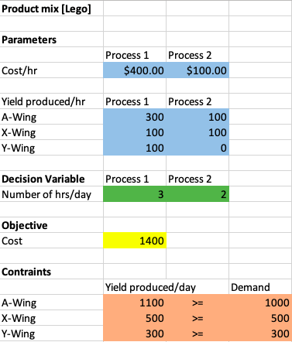
Sensitivity Report
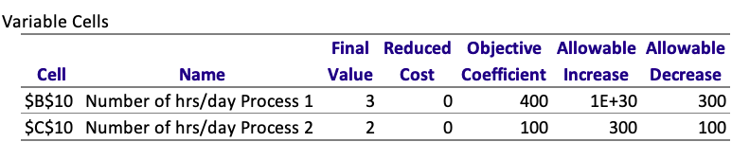
Now let’s look at the Sensitivity Report for the variable cells. The allowable increase and allowable decrease indicate how much the coefficient of unit cost for Process 1 in the objective, currently 400, could change before the optimal time mix would change. If the coefficient of Process 1 stays within this allowable range, from 100 (decrease of 300) to infinite, the optimal time mix—the set of values in the decision variable cells—does not change at all. However, outside of these limits, the optimal mix between Process 1 and Process 2 might change.
The reduced costs in the second column indicate, in general, how much the objective coefficient of a decision variable that is currently 0 or at its upper bound must change before that variable changes (becomes positive or decreases from its upper bound). The reduced cost for any variable between 0 and its upper bound in the optimal solution is irrelevant.
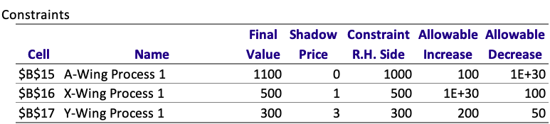
Now let’s look at the Sensitivity Report for the constraints. Each row in this section corresponds to a constraint. The report indicates how much these right-side constants can change before the optimal solution changes. A shadow price indicates the change in the objective when a right-side constant changes. A shadow price is reported for each constraint. For example, the shadow price for the demand of product Y-Wing constraint is 3. This means that if the right side of this constraint increases by one unit, from 300 to 303, the optimal value of the objective will increase by $3. It works in the other direction as well. If the right side of this constraint decreases by one hour, from 300 to 297, the optimal value of the objective will decrease by $3. However, as the right side continues to increase or decrease, this $3 change in the objective might not continue. This is where the reported allowable increase and allowable decrease are relevant. As long as the right side increases or decreases within its allowable limits, the same shadow price of 3 still applies. Beyond these limits, however, a different shadow price might apply.

